
Faculty of Science

Course: CSCI 2020u – Software System Development & Integration
Component: Assignment
Weight: 10%
Deadline: March 6, 2019 (due by 11:59pm)

Collaboration Policy
You are permitted to work on this assignment in a team, and submit the results as a team. For this sort of assignment, with an open-ended component, the collaboration between multiple team members can be beneficial. Between groups, however, please limit the discussion to the level of general strategy (not code). Groups of size 2 are recommended. Larger groups will be considered with the proviso that the marker will mark your assignment with higher expectations. In any case, be sure that all members of the team fully understand all code, otherwise they will miss intended learning objectives, which may be a considerable disadvantage at exam time.

How to Submit
You will maintain a git repository for this assignment, which is a public repository. To submit the assignment, create a single file ‘README.txt’ that contains instructions on how to download, compile, and run your codes for each question. A .zip, .7z, or .rar file will not be acceptable. Also submit this word file (once you complete) into related drop box on Blackboard before deadline.

Note: Comments are mandatory. Failure to properly document your program will result in a deduction on the marks you receive for this (and any other) assignment.

Remember:
You need to complete this file and submit it in related drop box on Blackboard, in addition to uploading your codes in your git repository, before deadline.

Question 1: Displaying Three Cards

Problem Description:
Display a frame that contains three labels. Each label displays a card, as shown in the figure below. The card image files are named 1.png, 2.png, ..., 54.png and stored in the image/card directory. All three cards are distinct and selected randomly.

The image icons can be found in the attached card folder.

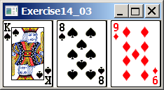

Your Task:
- Create three ImageView and set their icons using the images.
- Display three images from 54 image cards randomly.

Your Code:

package sample;
/* Author: Hassan Tariq
Course: CSCI 2020U
Question 1: Output 3 random cards
*/
import javafx.application.Application;
import javafx.geometry.Pos;
import javafx.scene.Scene;
import javafx.scene.layout.GridPane;
import javafx.stage.Stage;
import javafx.scene.image.ImageView;
public class Main extends Application {
@Override
public void start(Stage primaryStage) {
GridPane pane = new GridPane();
pane.setAlignment(Pos.CENTER);
pane.setHgap(5);
int random1 = (int)(Math.random() * 54 + 1);
int random2 = (int)(Math.random() * 54 + 1);
int random3 = (int)(Math.random() * 54 + 1);
//create random file url to mimic random card assignment
String url1 = "image/card/" + String.valueOf(random1) + ".png";
String url2 = "image/card/" + String.valueOf(random2) + ".png";
String url3 = "image/card/" + String.valueOf(random3) + ".png";
//create imageview of url previously created
ImageView imageView1 = new ImageView(url1);
ImageView imageView2 = new ImageView(url2);
ImageView imageView3 = new ImageView(url3);
//add to gridpane
pane.add(imageView1, 0, 0);
pane.add(imageView2, 1, 0);
pane.add(imageView3, 2, 0);
// Create a scene and place it in the stage
Scene scene = new Scene(pane);
primaryStage.setTitle("Question1"); // Set the stage title
primaryStage.setScene(scene); // Place the scene in the stage
primaryStage.show(); // Display the stage
}
public static void main(String[] args) {
launch(args);
}
}

Screen shots:
Include two screen shots here:
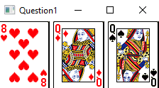
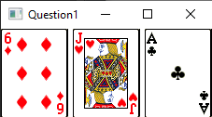

Question 2: Investment-Value calculator

Problem Description:
Write a program that calculates the future value of an investment at a given interest rate for a specified number of years. The formula for the calculation is as follows:

futureValue = investmentAmount * (1 + monthlyInterestRate)years*12

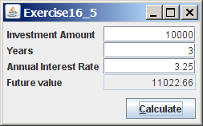

Your Task:
Use text fields for interest rate, investment amount, and years. Display the future amount in a text field when the user clicks the Calculate button, as shown in the figure.

Your Code:
package sample;
/* Author: Hassan Tariq
Course: CSCI 2020U
Question 2: Investment Value Calculator
*/
import javafx.application.Application;
import javafx.geometry.Pos;
import javafx.scene.Scene;
import javafx.scene.control.Button;
import javafx.scene.control.Label;
import javafx.scene.control.TextField;
import javafx.scene.layout.GridPane;
import javafx.stage.Stage;
public class Main extends Application {
@Override
public void start(Stage primaryStage) {
//create text fields and button
TextField invest = new TextField ();
TextField years = new TextField ();
TextField annualRate = new TextField ();
TextField futureValue= new TextField ();
Button calculate = new Button("Calculate");
GridPane grid = new GridPane();
grid.setAlignment(Pos.CENTER_RIGHT);
grid.setVgap(4);
grid.setHgap(10);
//add all labels and text fields to grid
grid.add(new Label("Investment Amount "), 0, 0);
grid.add(invest, 1, 0);
grid.add(new Label("Years "), 0, 1);
grid.add(years, 1, 1);
grid.add(new Label("Annual Interest Rate "), 0, 2);
grid.add(annualRate, 1, 2);
grid.add(new Label("Future Value "), 0, 3);
grid.add(futureValue, 1, 3);
grid.add(calculate,1,4);
//create scene
Scene scene = new Scene(grid);
primaryStage.setTitle("Question2"); // Set the stage title
primaryStage.setScene(scene); // Place the scene in the stage
primaryStage.show(); // Display the stage
calculate.setOnAction(action -> {
futureValue.setText(Double.parseDouble(invest.getText()) *
Math.pow(1 + Double.parseDouble(annualRate.getText())/100, Double.parseDouble(years.getText())) + "");
});
}
public static void main(String[] args) {
launch(args);
}
}

Screen shots:
Include two screen shots here:
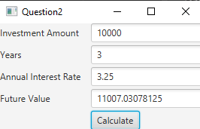
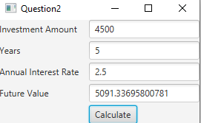

Question 3: Dragging Points on a Circle

Problem Description:
Draw a circle with three random points on the circle. Connect the points to form a triangle. Display the angles in the triangle. Use the mouse to drag a point along the perimeter of the circle. As you drag it, the triangle and angles are redisplayed dynamically.

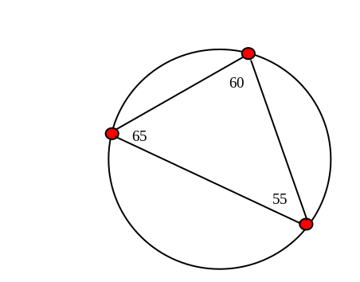

Here is the formula to compute angles:

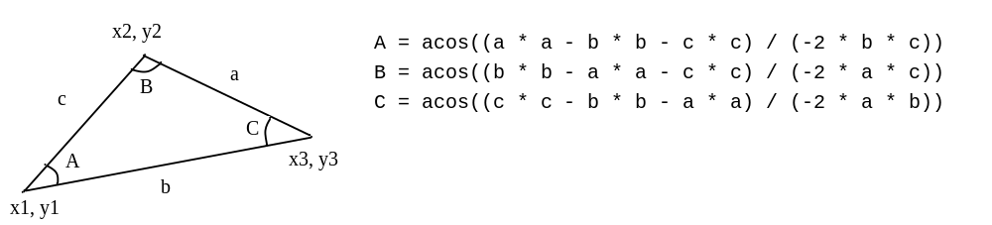

Your Code:
package sample;
/* Author: Hassan Tariq
Course: CSCI 2020U
Question 3: Dynamic triangle change with angles
*/
import javafx.application.Application;
import javafx.scene.Scene;
import javafx.scene.shape.Polygon;
import javafx.scene.shape.Circle;
import javafx.scene.text.Text;
import javafx.scene.paint.Color;
import javafx.collections.ObservableList;
import javafx.scene.layout.Pane;
import javafx.stage.Stage;
import java.util.ArrayList;
public class Main extends Application {
@Override
public void start(Stage primaryStage) {
// Create a pane
Pane pane = new Pane();
Circle circle = new Circle(150, 150, 100);
circle.setFill(Color.TRANSPARENT);
circle.setStroke(Color.BLACK);
pane.getChildren().add(circle);
//create the three points of the circle
//set circles stroke/fill to black/red
Circle p1 = new Circle(250, 150, 5);
p1.setFill(Color.RED);
p1.setStroke(Color.BLACK);
Circle p2 = new Circle(50, 150, 5);
p2.setFill(Color.RED);
p2.setStroke(Color.BLACK);
Circle p3 = new Circle(150, 50, 5);
p3.setFill(Color.RED);
p3.setStroke(Color.BLACK);
//array list for storing of points
ArrayList<Circle> points = new ArrayList<>();
points.add(p1);
points.add(p2);
points.add(p3);
// Place nodes in the pane
drawTriangle(pane, points);
pane.getChildren().addAll(p1, p2, p3);
placeText(pane, points);
// Create and register the handle
pane.setOnMouseDragged(e -> {
for (int i = 0; i < points.size(); i++) {
if (points.get(i).contains(e.getX(), e.getY())) {
pane.getChildren().clear();
points.get(i).setCenterX(e.getX());
points.get(i).setCenterY(e.getY());
drawTriangle(pane, points);
pane.getChildren().addAll(p1, p2, p3);
pane.getChildren().add(circle);
placeText(pane, points);
}
}
});
// Create a scene and place it in the stage
Scene scene = new Scene(pane, 300, 300);
primaryStage.setTitle("Q3"); // Set the stage title
primaryStage.setScene(scene); // Place the scene in the stage
primaryStage.show(); // Display the stage
}
public static void main(String[] args) {
launch(args);
}
//to update the text points on the vertices
static void placeText(Pane pane, ArrayList<Circle> points) {
double[] sides = getSides(points);
double[] angles = getAngles(sides);
pane.getChildren().add(new Text(points.get(0).getCenterX(),
points.get(0).getCenterY() - 5, String.format("%.1f", angles[0])));
pane.getChildren().add(new Text(points.get(1).getCenterX(),
points.get(1).getCenterY() - 5, String.format("%.1f", angles[1])));
pane.getChildren().add(new Text(points.get(2).getCenterX(),
points.get(2).getCenterY() - 5, String.format("%.1f", angles[2])));
}
//array list of sides of triangles
static double[] getSides(ArrayList<Circle> points) {
double[] sides = new double[3];
sides[0] = Math.sqrt(Math.pow(points.get(0).getCenterX() -
points.get(1).getCenterX(), 2) + Math.pow(points.get(0).getCenterY() -
points.get(1).getCenterY(), 2));
sides[1] = Math.sqrt(Math.pow(points.get(1).getCenterX() -
points.get(2).getCenterX(), 2) + Math.pow(points.get(1).getCenterY() -
points.get(2).getCenterY(), 2));
sides[2] = Math.sqrt(Math.pow(points.get(2).getCenterX() -
points.get(0).getCenterX(), 2) + Math.pow(points.get(2).getCenterY() -
points.get(0).getCenterY(), 2));
return sides;
}
//array of angles
static double[] getAngles(double[] s) {
double[] angles = new double[3];
//use given formula with some modification
angles[0] = Math.toDegrees(Math.acos((s[0] * s[0] - s[1] *
s[1] - s[2] * s[2]) / (-2 * s[1] * s[2])));
angles[1] = Math.toDegrees(Math.acos((s[1] * s[1] - s[0] *
s[0] - s[2] * s[2]) / (-2 * s[0] * s[2])));
angles[2] = Math.toDegrees(Math.acos((s[2] * s[2] - s[1] *
s[1] - s[0] * s[0]) / (-2 * s[0] * s[1])));
return angles;
}
//create shape of triangle (polygon)
private void drawTriangle(Pane pane, ArrayList<Circle> point) {
Polygon polygon = new Polygon();
pane.getChildren().add(polygon);
ObservableList<Double> points = polygon.getPoints();
for (int i = 0; i < point.size(); i++) {
points.add(point.get(i).getCenterX());
points.add(point.get(i).getCenterY());
}
polygon.setFill(Color.WHITE);
polygon.setStroke(Color.BLACK);
}
}

Screen shots:
Include two screen shots here:
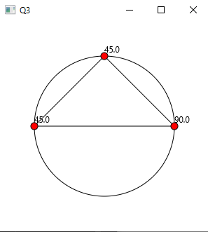
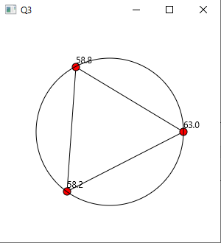

Question 4: Histogram

Problem Description:
Develop a program that displays a histogram to show the occurrences of each letter in a text area. The histogram should show the occurrences of each letter in a text file, as shown in the following figure. Assume that the letters are not case sensitive.

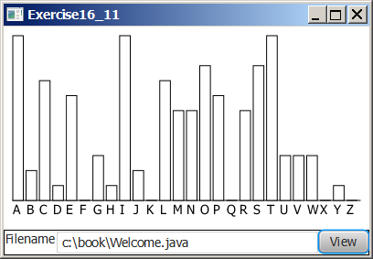

Your Task:
- Place a pane that will display the histogram in the center of the frame.
- Place a label and a text field in a panel, and put the panel in the south side of the frame. The text file will be entered from this text field.
- Pressing the Enter key on the text field causes the program to count the occurrences of each letter and display the count in a histogram.

Your Code:
package sample;
/* Author: Hassan Tariq
Course: CSCI 2020U
Question 4: Histogram of letter frequency
*/
import javafx.application.Application;
import javafx.geometry.VPos;
import javafx.scene.Scene;
import javafx.scene.control.Button;
import javafx.scene.control.ContentDisplay;
import javafx.scene.control.Label;
import javafx.scene.control.TextField;
import javafx.scene.layout.GridPane;
import javafx.scene.layout.HBox;
import javafx.scene.layout.VBox;
import javafx.scene.paint.Color;
import javafx.stage.Stage;
import javafx.scene.shape.Rectangle;
import java.io.IOException;
import java.util.Scanner;
public class Main extends Application{
public void start(Stage primaryStage) {
//Create textfield and button
TextField fileName = new TextField();
Label labelFile = new Label("Filename: ", fileName);
Button view = new Button("View");
labelFile.setContentDisplay(ContentDisplay.RIGHT);
fileName.setPrefColumnCount(20);
//add hbox to vbox to have separate non dynamic boxes
//so this hbox will not interfere with spacing of gridpane
HBox hBox = new HBox(labelFile, view);
VBox vBox = new VBox();
//create action event for inputting file name
view.setOnAction(e-> {
java.io.File file = new java.io.File(fileName.getText());
//error check for file existence
if (file.exists()) {
System.out.println(readFile(file));
int[] count = count(readFile(file));
char[] chars = new char[26];
Rectangle[] rectangles = new Rectangle[26];
for (int i = 0; i < 26; i++) {
chars[i] = (char) ('A' + i);
System.out.print(chars[i] + ": ");
System.out.print(count[i] + " ");
}
GridPane grid = new GridPane();
grid.setHgap(2);
for (int i = 0; i < 26; i++) {
rectangles[i] = new Rectangle(10, count[i]*10);
rectangles[i].setStroke(Color.BLACK);
rectangles[i].setFill(Color.WHITE);
Label label = new Label(chars[i] + "", rectangles[i]);
label.setContentDisplay(ContentDisplay.TOP);
grid.add(label, i , 0);
GridPane.setValignment(label, VPos.BASELINE);
}
vBox.getChildren().add(grid);
} else {
System.out.println("File does not exist!");
}
});
//add all remaining boxes
vBox.getChildren().add(hBox);
Scene scene = new Scene(vBox, 400, 1000);
primaryStage.setTitle("Q4"); // Set the stage title
primaryStage.setScene(scene); // Place the scene in the stage
primaryStage.show(); // Display the stage
}
public static void main(String[] args) {
launch(args);
}
//readFile function that reads file and creates single string to count frequency
public static String readFile(java.io.File file) {
Scanner scanner;
String s = "";
try {
scanner = new Scanner(file);
while (scanner.hasNextLine()) {
s += scanner.nextLine();
}
} catch (IOException ex) {
}
s = s.toUpperCase();
return s;
}
//count function that reads the single string created by readFile to get frequency
public static int[] count (String s) {
int count[] = new int[26];
for (int i = 0; i < s.length(); i++) {
char character = s.charAt(i);
if (Character.isLetter(character)) {
count[character-'A']++;
}
}
return count;
}
}

Screen shots:
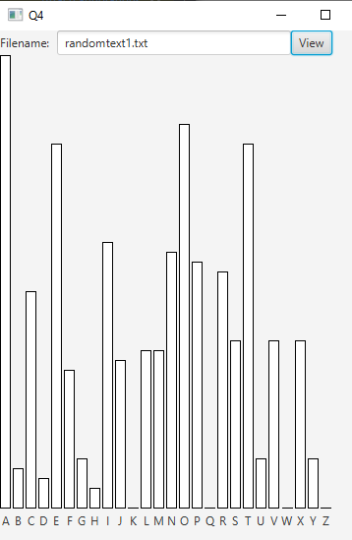
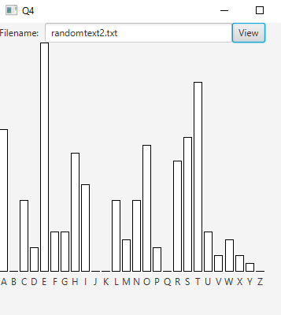
Remember:

You need to complete this file and submit it in related drop box on Blackboard, in addition to uploading your codes in your git repository, before deadline.

